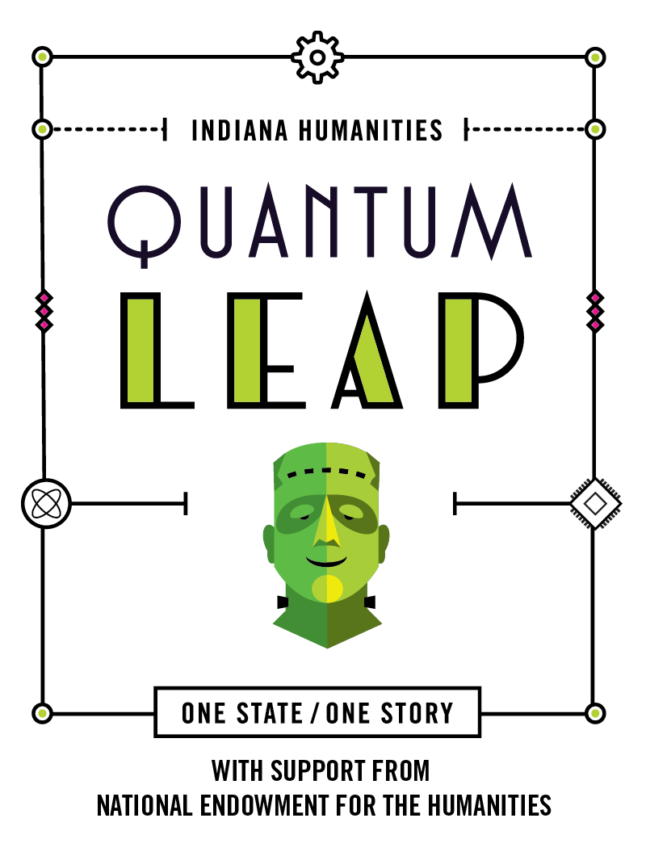 | ONE STATE / ONE STORY  FRANKENFEST GRANT  FINAL BUDGET FORM

HOST ORGANIZATION:

HOST COORDINATOR NAME:

Please complete this form and attach it to the online final report form to show how you used your Frankenfest Grant and what additional support you raised in your community.

An example budget form is provided in the One State / One Story: Frankenstein Program Guide. Typical item categories include but aren’t limited to speaker honoraria, books, food/drink, printing, advertising, space rental, equipment rental, materials. For each item, please briefly note what it is, e.g., “$225-tent rental,” or “$40-2 large print editions of Frankenstein.” The total amount of the Indiana Humanities funds should not be greater $1,000.

Please note: you cannot use your Frankenfest Grant to purchase alcohol, though you may list donated alcohol or alcohol purchased with other funds in your in-kind or out-right match.

Item/Category | Community Read Grant | In-Kind Match* | Outright Match**
Sub-Total:
TOTAL EVENT BUDGET
(Total of Community Read Grant, in-kind and out-right match.)
Insert additional rows as necessary.

*In-kind match includes the value of services or space donated/contributed to make the event possible.
**Outright match includes direct costs (e.g., purchases) contributed by the host org., community partners, local businesses or other funders.

Please explain sources of in-kind and outright match (max 500 words):

