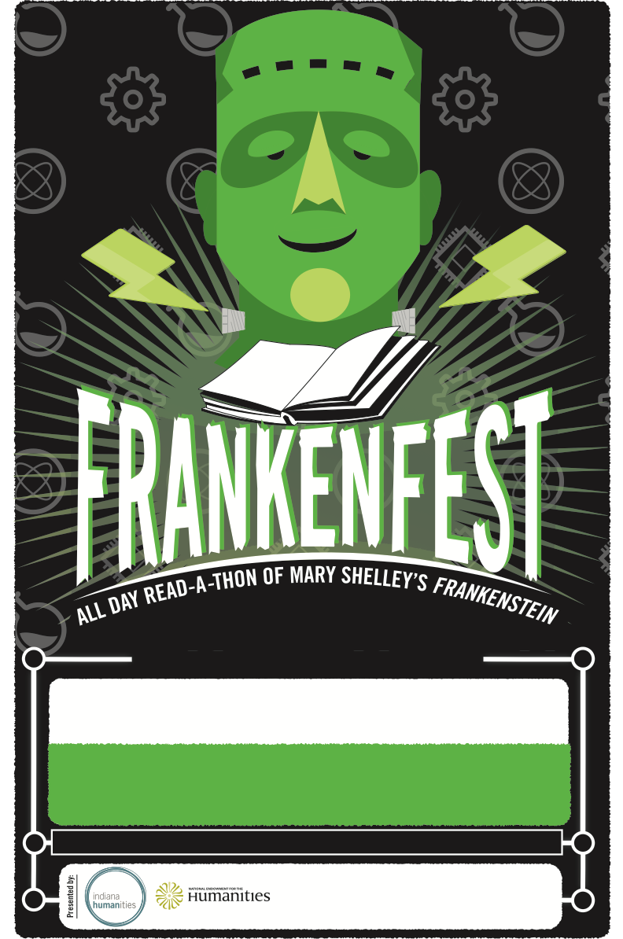

Lorem ipsum dolor sit amet, consectetuer adipiscing elit, sed diam nonummy nibh euismod tincidunt ut laoreet dolore magna aliquam erat volutpat. Ut wisi enim ad minim veniam, quis nostrud exerci tation ullamcorper suscipit lobortis nisl ut aliquip ex ea commodo consequat. Duis autem vel eum iriure dolor

OCT. 20 | YOUR LOCATION

1234 YOUR STREET | YOUR TOWN, INDIANA 47777

EXAMPLE: A read-a-thon of the novel featuring VIP

EXAMPLE: Kid friendly art activities

EXAMPLE: Curatorial talks on items from the museum

(think brains in jars, antique surgical equipment)

EXAMPLE: A read-a-thon of the novel featuring VIP

EXAMPLE: Kid friendly art activities

EXAMPLE: Curatorial talks on items from the museum

(think brains in jars, antique surgical equipment)